Preparing your files for Printing through Simlab – June 2018
Simlab ( www.simlab.co.uk) has taken over from proam imaging .
Please follow instructions carefully as per screenshot below.
Your images must be sized A3 ( 16.5 X 11.7 INCHES) or to the appropriate size you want your images to be printed.
Put images in a folder named A3 gloss or A3 lustre
PLEASE PAY WHEN ORDERING - A3 prints £1.10 excl vat
A4 prints £0.65p excl vat
Delivery £5.50 to be split between the people ordering prints.
For optimum results please make sure your image has an sRGB colour
profile embedded, not tagged and that the resolution is 300dpi, saved in JPEG file format.
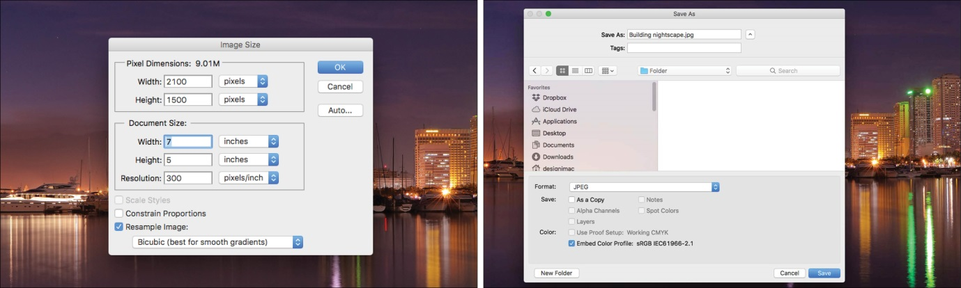
YOUR IMAGES WILL ONLY BE UPLOADED TO SIMLAB THEY WILL NOT BE CHECKED, IT IS THE RESPONSIBILITY OF THE AUTHOR TO ENSURE CORRECT SIZING ETC.

